CSCE 5430 SOFTWARE ENGINEERING

9/9/2020

Group Name: Mystic Gang

Group Members:

1. Abhinav Mamidipelly
2. Harshavardhan Reddy Goli
3. Prakyath Reddy Kandimalla
4. Udhaya Kumar Gutta

Image Based Food Size and Calorie Estimation

Using CNN classifier

Table of Contents

Abstract……………………………………………………………………………………………………………………………….3

1. Introduction……………………………………………………………………………………………………………………3
2. Related Work………………………………………………………………………………………………………………….4
3. Project Plan…………………………………………………………………………………………………………………….5
   1. Gantt Chart……………………………………………………………………………………………………………….6
   2. Software Requirements…………………………………………………………………………………………….6
4. Risk Management……………………………………………………………………………………………………………7
   1. Risk Identification……………………………………………………………………………………………………...7
   2. Risk Monitoring and Control……………………………………………………………………………………...7
5. Team Member’s Roles for the Project………………………………………………………………………………7
6. References……………………………………………………………………………………………………………………….8

**ABSTRACT:** In our modern busy world, we must track our food calorie estimation to avoid the obesity related problems. In recent works many researches focuses on the food item identification detection system for calculating the Calorie Estimation using Deep Learning Techniques. Deep Learning is a part of the Artificial Intelligence that will used to build neural model features for prediction of the data from the unstructured data. By using the Deep Learning model, here we are proposing the concept of Image based food identification for calorie estimation. In this model we are using CNN (Convolutional Neural Networks) for prediction of the food item from the image. Based on the food name from the image we calculate the calories of the of food item. Based on the collection of the image dataset for training using CNN we can get the accurate results.

**1. INTRODUCTION**

In recent trends identification of food objects from the images is a popular and trending research topic, because of the food identification will help for the different purposes like name recognition, for calorie estimation, identification of the types of ingredients etc. In this paper focus on the identification of the calorie identification using CNN approach. Generally in machine learning techniques are depends on the four level approaches. First step is collection of the Input data. In this step we collect the input records which are labeled and supervised data. In second step, Feature Extraction is the process of identify the features for classifications. We define the class labels and other attributes which are depend on the class labels, the analyzers will define the feature selections model. Next step classify with any Machine learning algorithm. Based on the classification in the classification algorithm we can predict the result according to the given test data. In Fig 1 described clearly about the basic Machine Learning technique.

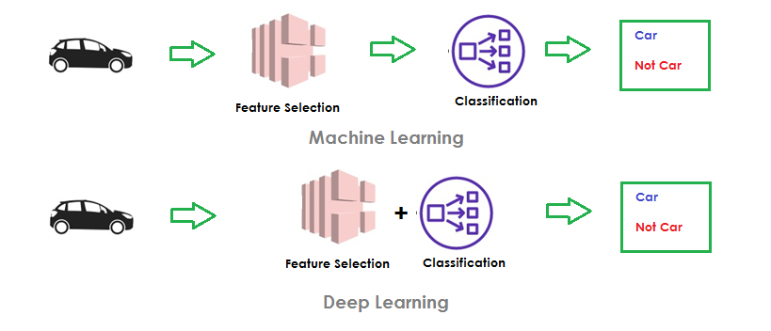

Fig 1. Machine Learning vs. Deep Learning

In our paper we demonstrated our prediction concept Deep Learning concepts. Deep Learning is the concept which includes three major steps. First one is same like Machine Learning, collection of the input data. But here we can also provide unstructured and unlabeled data like images, text etc. In second step we can combine the Feature Extraction and Classification algorithm. In Machine Learning the analyst define the features of the input data, but here the collection and extraction of the features of the input data no need to define, the features will automatically structured and extracted. In the last phase prediction will same as Machine learning, prediction of the result according to the classifications.

For object identification CNN models have achieved lot of goals by comparatively Machine Learning models. Many applications have implemented CNN models for object identifications like face recognitions, identification facial expression etc. By taking motivations of those literatures we are implementing food image identification for calories detection.

**2. Related Work**

Miyazaki et al. [1] proposed dietary management application that can manage the user’s meals of the everyday by storing and analyzing images of the meals. In this concept authors proposed the Dietary Application which will collect the features from the images and apply the classification algorithm of k-means to form the clusters. Here they used concept of BoF, it means it collect the Bag of Features mainly depends on the color and shapes of the food items, by the time of the prediction of the food it will convert it to the pixels and compare with the existing food category images. In this they taken the food images of five categories those are grains, meat, fruits, vegetables and dairy products.

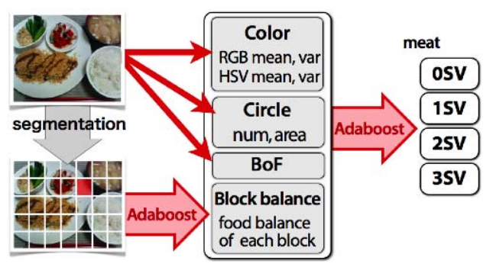

Fig 2: Overview of Dietary Application

In this survey food image will convert into pixels and it turns to futures like colors and shapes like circle area etc. Application will store the images and data of the images in the form of the SV means servings. As per we discussed in the introduction this concept was depend on the features classification the will developer has to be set.

Chen et al. [1] proposed dietary management concept by using machine learning classification that can identification of the food for calories estimation by analyzing images of the food. In this concept authors proposed the Dietary Application which will collect the features from the images and apply the classification algorithm of Support Vector Machine.

**3. Project Plan**

In our current lifestyle we are taking unhealthy food and high calorie food, this leads to lots of diseases like obesity, thyroid etc. We must track our calories of food that we are taking to avoid the diseases. But calculating the calories of food what we are taking is difficult and manual process. We have few web services that provide calories of the food items. But those are manually we need compare and collect. If we don’t know the ingredients of the food item or if we don’t know the name of the food, we can’t get to know about the calories of food. Based on these advantages we are proposing the system that will identify the name of the food from the image and calculate the calories based on the quantity of food. For calorie estimation we are using Deep Learning Techniques.

Deep Learning is a part of the Artificial Intelligence that will used to build neural model features for prediction of the data from the unstructured data. In this model we are using CNN (Convolutional Neural Networks) for prediction of the food item from the image. Based on the food name from the image we calculate the calories of the of food item. Based on the collection of the image dataset for training using CNN we can get the accurate results.

In our system,

* We identify problem of food calorie estimation.
* We identify the problems in machine learning model for static feature selection.
* We identify the advantages of CNN models based on the dynamical feature selection.

We develop project with following software requirements

* In our research, we build our system in desktop-based application. We use Python as a programming language and from Python API’s we have used Pyqt5 concepts for building GUI components.
* For frontend in our application we design with PyQt5 Tools.
* For backend to store our data we used MySQL server for performing RDBMS concepts from our application.

**Gantt chart:**

**Software Requirements**

|  |  |
| --- | --- |
| Technology | Python 3.6 |
| Operating System | Windows Family |
| IDE | VS Code |
| Database Server | MySQL |
| Front Design Technology | PyQt5 |

**4. Risk Management**

**4.1 Risk Identification**

The Risk Register usually includes the following:

* For dataset collection, generally for classifying the image object dynamically with dynamic collection features of the objects is very risk. We need to collect the lots of images for an object like ‘Ice Cream’.
* For User interface we need to build a desktop application.
* In desktop-based application we cannot satisfy the user expectation in terms of GUI components because of we don’t have much GUI components in the desktop frontend language.

**4.2 Risk Monitoring and Control**

In this process we identify the problems and analyze the solutions. We mainly monitor the identified products and monitor the new products.

Activities involved in Risk Monitoring include:

* Collection of datasets.
* Training of the dataset.
* Identify new risks.
* Track risk response.

**5.Team Members Role’s for the Project:**

|  |  |  |  |
| --- | --- | --- | --- |
| Member Name | Contribution Description | Overall Description (%) | Roles |
| Abhinav Mamidipelly | Software Requirements, Plan | 25 | Back-end and Databases |
| Harshavardhan Reddy Goli | Project Plan | 25 | Front-end and Back end |
| Prakyath Reddy Kandimalla | Related Work | 25 | Full-Fledged Front end |
| Udhaya Kumar Gutta | Risk Management | 25 | Full-Fledged  Back end |

**6.REFERENCES**

[1] T. Miyazaki, De. S. G. Chamin, and K. Aizawa, “Image-based calorie content estimation for dietary assessment,” in IEEE International Symposium on Multimedia, pp. 363–368, 2011.

[2] M. Chen, Y. Yang, C. Ho, S. Wang, S. Liu, E. Chang, C. Yeh, and M. Ouhyoung, “Automatic Chinese food identification and quantity estimation,” in Proc. of SIGGRAPH Asia Technical Briefs, p. 29, 2012.

[3] F. Kong and J. Tan, “Dietcam: Automatic dietary assessment with mobile camera phones,” in Proc. of Pervasive and Mobile Computing, pp. 147–163, 2012.

[4] C. Xu, Y. He, N. Khannan, A. Parra, C. Boushey, and E. Delp, “Image-based food volume estimation,” in Proceedings of the international workshop on Multimedia for cooking & eating activities, pp. 75–80, 2013.